**PROGRAMMING FUNDAMENTAL LAB 3**

TASK 1:

GITHUB:<https://github.com/Hanya321/C-Programming-Lab/blob/main/README.md>

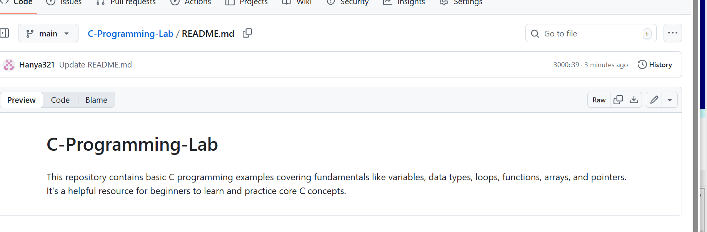

TASK 2:

|  |
| --- |
| #include<stdio.h>  int main()  {printf("Hello World");  return 0;  } |

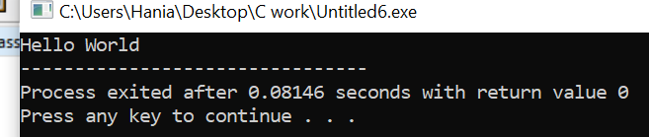

TASK 3:

|  |
| --- |
| #include<stdio.h>  int main()  {int a,b,temp;  printf("Enter first number:");  scanf("%d",&a);  printf("Enter second number:");  scanf("%d",&b);  printf("Numbers before swapping:");  printf("\nFirst Number:%d",a);  printf("\nSecond Number:%d",b);  temp=b;  b=a;  a=temp;  printf("\nNumbers after swapping:");  printf("\nFirst Number:%d",a);  printf("\nSecond Number:%d",b);  return 0;  } |

